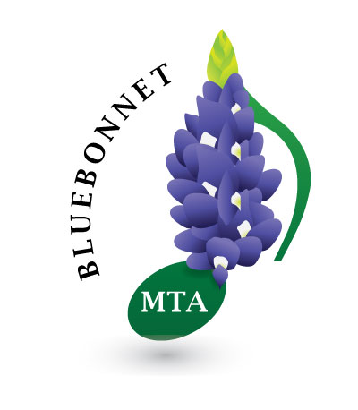
Bluebonnet
In Person Recitals

Students of Bluebonnet teachers in Festivals are invited to play their favorite pieces in Recitals in the fall, spring or summer.

The in person Recitals will be held at Steinway Piano Gallery which is located 12980 Research Blvd., Hwy 183N
(between Spicewood Springs & Anderson Mill)
phone: 512-258-6100
Registration of students should be mailed or given to the Recital Chair two weeks before the recitals. $5 registration fee per student goes to chairman
Time limit seven minutes per performer.
Out of association teachers are invited. There will be a $10 fee per student for out of association students. Limit first 10 out of association students that apply.

